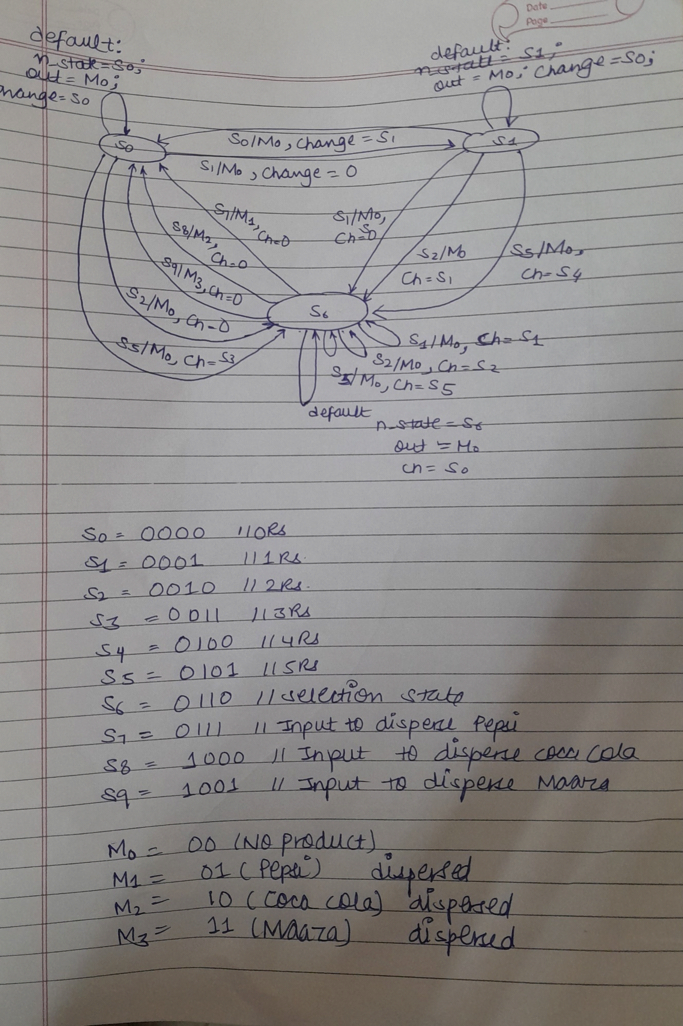Vending Machine Code:-

`timescale 1ns / 1ps

//////////////////////////////////////////////////////////////////////////////////

// Company:

// Engineer:

//

// Create Date: 15.04.2023 20:07:51

// Design Name:

// Module Name: vending_machine

// Project Name:

// Target Devices:

// Tool Versions:

// Description:

//

// Dependencies:

//

// Revision:

// Revision 0.01 - File Created

// Additional Comments:

//

//////////////////////////////////////////////////////////////////////////////////

module vending_machine(

input clock,rst,

input [3:0] in,

output reg[1:0] out,

output reg [3:0] change,

output reg [1:0] changehb

);

wire clk;

parameter s0= 4'b0000;//Rs.0

parameter s1= 4'b0001;//Rs.1

parameter s2= 4'b0010;//Rs.2

parameter s3= 4'b0011;

parameter s4= 4'b0100;

parameter s5= 4'b0101;//Rs.5

parameter s6= 4'b0110;

parameter s7= 4'b0111;

parameter s8= 4'b1000;

parameter s9= 4'b1001;

parameter m0= 2'b00; // No product dispersed

parameter m1= 2'b01; //Pepsi dispersed

parameter m2= 2'b10; //Coca Cola dispersed

parameter m3= 2'b11; //Maaza dispersed

reg[3:0] c_state,n_state;

always@(posedge clk)

begin

if (rst==1)

begin

c_state=0;

n_state=0;

change=s0;

changehb=2'b00;

end

else

begin

c_state=n_state;

case(c_state)

s0 : begin

if(in==s1)

begin

n_state=s1;

out=m0;

change=s0;

end

else if(in==s2)

begin

n_state=s6;

out=m0;

change=s0;

end

else if(in==s5)

begin

n_state=s6;

out=m0;

change=s1;

changehb=2'b10;

end

else

begin

n_state=s0;

out=m0;

change=s0;

end

end

s1:

begin

if(in==s1)

begin

n_state=s6;

out=m0;

change=s0;

end

else if(in==s2)

begin

n_state=s6;

out=m0;

change=s1;

end

else if(in==s5)

begin

n_state=s6;

out=m0;

change=s2;

changehb=2'b10;

end

else if(in==s0)

begin

n_state=s0;

out=m0;

change=s1;

end

else

begin

n_state=s1;

out=m0;

change=s0;

end

end

s6:

begin

if(in==s7)

begin

n_state=s0;

out=m1;

change=s0;

changehb=2'b00;

end

else if(in==s8)

begin

n_state=s0;

out=m2;

change=s0;

changehb=2'b00;

end

else if(in==s9)

begin

n_state=s0;

out=m3;

change=s0;

changehb=2'b00;

end

else if(in==s1)

begin

n_state=s6;

out=m0;

change=s1;

changehb=2'b00;

end

else if(in==s2)

begin

n_state=s6;

out=m0;

change=s2;

changehb=2'b00;

end

else if(in==s5)

begin

n_state=s6;

out=m0;

change=s5;

changehb=2'b00;

end

else

begin

n_state=s6;

out=m0;

change=s0;

changehb=2'b00;

end

end

default:

begin

n_state=s0;

out=m0;

change=s0;

end

endcase

end

end

always @ (posedge clk)begin

if(out==2'b01)

$display("pepsi dispached");

else if(out==2'b10)

$display("cocacola dispached");

else if(out==2'b11)

$display("Maaza dispached");

end

endmodule

testbench code:-

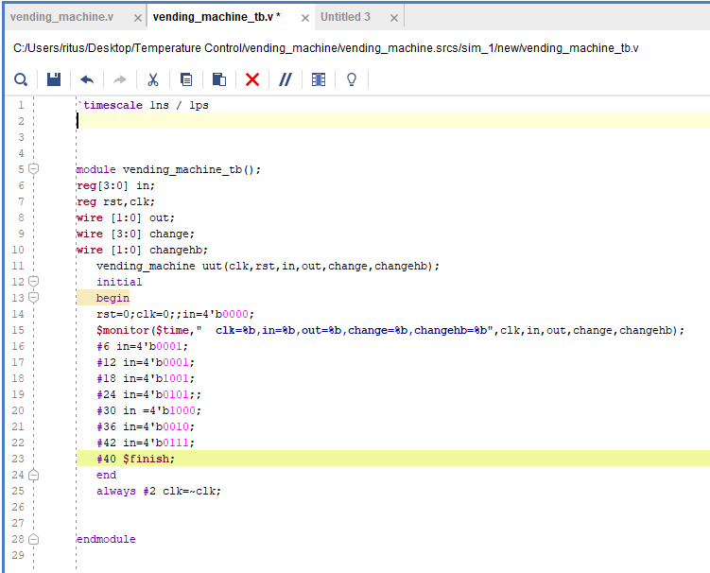

`timescale 1ns / 1ps

//////////////////////////////////////////////////////////////////////////////////

// Company:

// Engineer:

//

// Create Date: 16.04.2023 02:15:56

// Design Name:

// Module Name: vending_machine_tb

// Project Name:

// Target Devices:

// Tool Versions:

// Description:

//

// Dependencies:

//

// Revision:

// Revision 0.01 - File Created

// Additional Comments:

//

//////////////////////////////////////////////////////////////////////////////////

module vending_machine_tb();

reg[3:0] in;

reg rst,clk;

wire [1:0] out;

wire [3:0] change;

wire [1:0] changehb;

vending_machine uut(clk,rst,in,out,change,changehb);

initial

begin

rst=0;clk=0;;in=4'b0000;

$monitor($time," clk=%b,in=%b,out=%b,change=%b,changehb=%b",clk,in,out,change,changehb);

#6 in=4'b0001;

#12 in=4'b0001;

#18 in=4'b1001;

#24 in=4'b0101;;

#30 in =4'b1000;

#36 in=4'b0010;

#42 in=4'b0111;

#40 $finish;

end

always #2 clk=~clk;

endmodule

testbench output:-

run 1000ns

0 clk=0,in=0000,out=xx,change=xxxx,changehb=xx

2 clk=1,in=0000,out=00,change=0000,changehb=xx

4 clk=0,in=0000,out=00,change=0000,changehb=xx

6 clk=1,in=0001,out=00,change=0000,changehb=xx

8 clk=0,in=0001,out=00,change=0000,changehb=xx

10 clk=1,in=0001,out=00,change=0000,changehb=xx

12 clk=0,in=0001,out=00,change=0000,changehb=xx

14 clk=1,in=0001,out=00,change=0001,changehb=00

16 clk=0,in=0001,out=00,change=0001,changehb=00

18 clk=1,in=0001,out=00,change=0001,changehb=00

20 clk=0,in=0001,out=00,change=0001,changehb=00

22 clk=1,in=0001,out=00,change=0001,changehb=00

24 clk=0,in=0001,out=00,change=0001,changehb=00

26 clk=1,in=0001,out=00,change=0001,changehb=00

28 clk=0,in=0001,out=00,change=0001,changehb=00

30 clk=1,in=0001,out=00,change=0001,changehb=00

32 clk=0,in=0001,out=00,change=0001,changehb=00

34 clk=1,in=0001,out=00,change=0001,changehb=00

36 clk=0,in=1001,out=00,change=0001,changehb=00

Maaza dispached

38 clk=1,in=1001,out=11,change=0000,changehb=00

40 clk=0,in=1001,out=11,change=0000,changehb=00

42 clk=1,in=1001,out=00,change=0000,changehb=00

44 clk=0,in=1001,out=00,change=0000,changehb=00

46 clk=1,in=1001,out=00,change=0000,changehb=00

48 clk=0,in=1001,out=00,change=0000,changehb=00

50 clk=1,in=1001,out=00,change=0000,changehb=00

52 clk=0,in=1001,out=00,change=0000,changehb=00

54 clk=1,in=1001,out=00,change=0000,changehb=00

56 clk=0,in=1001,out=00,change=0000,changehb=00

58 clk=1,in=1001,out=00,change=0000,changehb=00

60 clk=0,in=0101,out=00,change=0000,changehb=00

62 clk=1,in=0101,out=00,change=0001,changehb=10

64 clk=0,in=0101,out=00,change=0001,changehb=10

66 clk=1,in=0101,out=00,change=0101,changehb=00

68 clk=0,in=0101,out=00,change=0101,changehb=00

70 clk=1,in=0101,out=00,change=0101,changehb=00

72 clk=0,in=0101,out=00,change=0101,changehb=00

74 clk=1,in=0101,out=00,change=0101,changehb=00

76 clk=0,in=0101,out=00,change=0101,changehb=00

78 clk=1,in=0101,out=00,change=0101,changehb=00

80 clk=0,in=0101,out=00,change=0101,changehb=00

82 clk=1,in=0101,out=00,change=0101,changehb=00

84 clk=0,in=0101,out=00,change=0101,changehb=00

86 clk=1,in=0101,out=00,change=0101,changehb=00

88 clk=0,in=0101,out=00,change=0101,changehb=00

cocacola dispached

90 clk=1,in=1000,out=10,change=0000,changehb=00

92 clk=0,in=1000,out=10,change=0000,changehb=00

94 clk=1,in=1000,out=00,change=0000,changehb=00

96 clk=0,in=1000,out=00,change=0000,changehb=00

98 clk=1,in=1000,out=00,change=0000,changehb=00

100 clk=0,in=1000,out=00,change=0000,changehb=00

102 clk=1,in=1000,out=00,change=0000,changehb=00

104 clk=0,in=1000,out=00,change=0000,changehb=00

106 clk=1,in=1000,out=00,change=0000,changehb=00

108 clk=0,in=1000,out=00,change=0000,changehb=00

110 clk=1,in=1000,out=00,change=0000,changehb=00

112 clk=0,in=1000,out=00,change=0000,changehb=00

114 clk=1,in=1000,out=00,change=0000,changehb=00

116 clk=0,in=1000,out=00,change=0000,changehb=00

118 clk=1,in=1000,out=00,change=0000,changehb=00

120 clk=0,in=1000,out=00,change=0000,changehb=00

122 clk=1,in=1000,out=00,change=0000,changehb=00

124 clk=0,in=1000,out=00,change=0000,changehb=00

126 clk=1,in=0010,out=00,change=0000,changehb=00

128 clk=0,in=0010,out=00,change=0000,changehb=00

130 clk=1,in=0010,out=00,change=0010,changehb=00

132 clk=0,in=0010,out=00,change=0010,changehb=00

134 clk=1,in=0010,out=00,change=0010,changehb=00

136 clk=0,in=0010,out=00,change=0010,changehb=00

138 clk=1,in=0010,out=00,change=0010,changehb=00

140 clk=0,in=0010,out=00,change=0010,changehb=00

142 clk=1,in=0010,out=00,change=0010,changehb=00

144 clk=0,in=0010,out=00,change=0010,changehb=00

146 clk=1,in=0010,out=00,change=0010,changehb=00

148 clk=0,in=0010,out=00,change=0010,changehb=00

150 clk=1,in=0010,out=00,change=0010,changehb=00

152 clk=0,in=0010,out=00,change=0010,changehb=00

154 clk=1,in=0010,out=00,change=0010,changehb=00

156 clk=0,in=0010,out=00,change=0010,changehb=00

158 clk=1,in=0010,out=00,change=0010,changehb=00

160 clk=0,in=0010,out=00,change=0010,changehb=00

162 clk=1,in=0010,out=00,change=0010,changehb=00

164 clk=0,in=0010,out=00,change=0010,changehb=00

166 clk=1,in=0010,out=00,change=0010,changehb=00

168 clk=0,in=0111,out=00,change=0010,changehb=00

pepsi dispached

170 clk=1,in=0111,out=01,change=0000,changehb=00

172 clk=0,in=0111,out=01,change=0000,changehb=00

174 clk=1,in=0111,out=00,change=0000,changehb=00

176 clk=0,in=0111,out=00,change=0000,changehb=00

178 clk=1,in=0111,out=00,change=0000,changehb=00

180 clk=0,in=0111,out=00,change=0000,changehb=00

182 clk=1,in=0111,out=00,change=0000,changehb=00

184 clk=0,in=0111,out=00,change=0000,changehb=00

186 clk=1,in=0111,out=00,change=0000,changehb=00

188 clk=0,in=0111,out=00,change=0000,changehb=00

190 clk=1,in=0111,out=00,change=0000,changehb=00

192 clk=0,in=0111,out=00,change=0000,changehb=00

194 clk=1,in=0111,out=00,change=0000,changehb=00

196 clk=0,in=0111,out=00,change=0000,changehb=00

198 clk=1,in=0111,out=00,change=0000,changehb=00

200 clk=0,in=0111,out=00,change=0000,changehb=00

202 clk=1,in=0111,out=00,change=0000,changehb=00

204 clk=0,in=0111,out=00,change=0000,changehb=00

206 clk=1,in=0111,out=00,change=0000,changehb=00

$finish called at time : 208 ns : File "C:/Users/ritus/Desktop/Temperature Control/vending_machine/vending_machine.srcs/sim_1/new/vending_machine_tb.v" Line 41

INFO: [USF-XSim-96] XSim completed. Design snapshot 'vending_machine_tb_behav' loaded.

INFO: [USF-XSim-97] XSim simulation ran for 1000ns

launch_simulation: Time (s): cpu = 00:00:01 ; elapsed = 00:00:07 . Memory (MB): peak = 801.594 ; gain = 0.000launch_simulation: Time (s): cpu = 00:00:01 ; elapsed = 00:00:10 . Memory (MB): peak = 804.344 ; gain = 0.000

